Our aim is that no one finds themselves alone and vulnerable on the streets at night.
We are creating a safe haven in the heart of the city.
We are also reaching out beyond Belfast to help vulnerable people across Northern Ireland.

SOS NI
SOS NI is a volunteer-centred charity that is making a real difference to children, young people, and adults on the streets of Belfast. It offers a unique mobile service that can be located wherever it is needed.

A Twin-Track Approach to Alcohol Safety
SOS Bus is a welfare service consisting of over 250 trained volunteers who offer up their free time to provide unconditional care, support, and medical intervention for vulnerable people on the streets of Belfast every weekend until 3.30am.

Working on the front line of Belfast’s night-time economy, SOS Bus has engaged with 283,000 people on the streets, provided in-depth medical and caring services to over 7,500 and has helped to save 25 lives.

The SOS NI Schools Education and Empowerment Programme works in schools across Northern Ireland to increase young people’s understanding of the effects of alcohol, equip them to deal with dangerous situations involving alcohol, and to engage their families to talk about alcohol and drugs at home.

Community
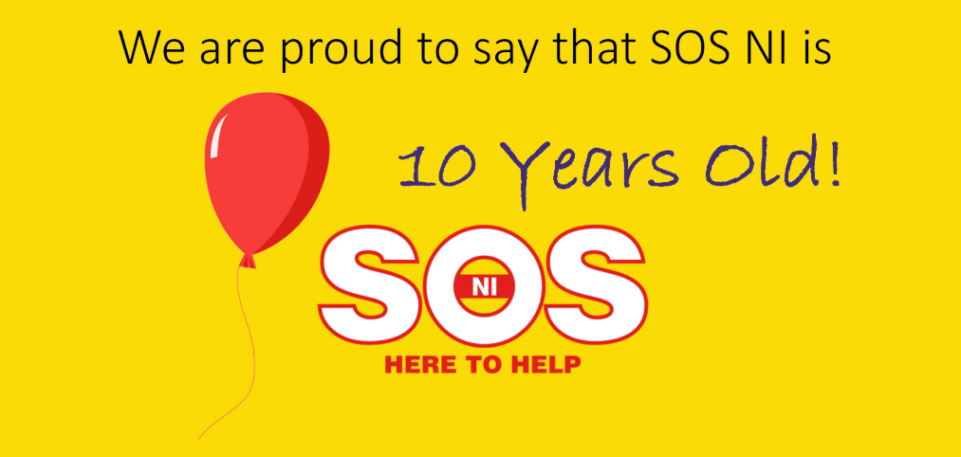
The SOS NI Food Programme collects perishable surplus food from supermarkets and distributors for delivery to over 50 charitable organisations who in turn help to feed over 1,500 people in Northern Ireland. Collections and deliveries are made 6 days a week by a team of 30 volunteers. In 2016, the programme distributed £317,349 worth of surplus food that would otherwise have been disposed of by supermarkets.

